Mobile SDK
Overview

Date: 26th August 2013
Revision: 1.0
Status: Published

Cúram Mobile SDK

Introduction
The intention of this document is to provide a high-level overview of the Cúram Mobile SDK. The aim of the Cúram Mobile SDK is to provide a set of tools to our customers and business partners that will enable them to develop Cúram mobile applications.

Problem Statement
    - Project Background
A large focus for IBM at present is Mobile support, including a Mobile First Agenda and a recent announcement of a Mobile stack offering. Industry Solutions is now embracing IBM's Mobile First Agenda and according to this directive, solutions will be developed with Mobile in mind from their earliest stages of design.
In addition to this we have a large number of customers requesting mobile support in some form. We have previously developed a Cúram mobile application for demo within the CCS project. It was a native iPhone application and was developed by an external company specializing in iPhone app development. It was very well received at user conferences in 2011. However, outsourcing mobile app development in this way is not a sustainable solution, and does not help our customers create similar apps.
Mobile support for Cúram is not aimed at the existing Cúram application, but at empowering our customers to create mobile Apps for specific social use cases. Developing with mobile first in mind is not suitable for the full Cúram application due to the existing client infrastructure and 20,000 product pages already in existence. The full Cúram Application running in a mobile environment is outside the scope of this document.
    - Users
The users are those who will use the features of the Mobile SDK and use the resulting applications. The users and their needs are as follows:
- Customer Developers: Require the ability to develop mobile applications for a Cúram application;
- Customer Users: Require targeted mobile applications, for multiple platforms, allowing them to perform specific social use cases;
- Business Partners/GBS: Require the ability to develop and deliver mobile applications for a Cúram application.
- Application Developers: Require the ability to develop and deliver mobile applications for a Cúram application.

Vision of the Solution
    - Vision Statement

A set of tools (SDK) enabling customers and business partners to develop Cúram mobile applications for multiple platforms.
    - List of Features
The Cúram Mobile SDK will include the following features:
- Cúram Data Service Layer: A CDEJ web-tier servlet enabling invocation of Cúram facades from JavaScript Ajax calls. The CDSL will also include JavaScript APIs to support invoking the servlet and handling data formatting and error scenarios.
- Mobile Centre of Competency (MCoC) Core Framework: A set of core JavaScript services that are commonly required by mobile applications, and will be supported as part of the offering.
- Integration with IBM WorkLight: The mobile IDE that will be used to aid development and testing of mobile applications for cross platform solutions.
- Offline Support: Basic support for implementing offline scenarios. This will leverage WorkLight’s JSONStore, for encrypted storage of content in mobile applications.
- Pagination: Basic support for mobile specific pagination scenarios that enable reduction of data sent to the mobile application.
- Authentication: Support for both integrated authentication with WorkLight and basic form based authentication.
    - Features That Will Not be Developed

To avoid any misunderstandings, the following are features that will not be implemented:
- Support for existing Cúram running on a mobile/tablet device;
Note: This is currently being progressed via a separate project, specifically the touch tolerant support project for 6.1.
- Support for feature phones, including SMS support;
Note: WorkLight supports SMS messages, where a third party SMS gateway can be configured to handle sending the messages. However, there is no plan to leverage this in the product as part of the mobile SDK.
- User Interface Library.
Dojo Mobile provides a library of widgets tailored for mobile applications.
    - Considerations
There are a number of additional factors for consideration by this project. For full details see the Issues Log.
- WorkLight support for WebLogic: WorkLight doesn’t support WebLogic and our solution depends on and leverages WorkLight features. We are pursuing the possibility of providing WebLogic support with WorkLight, but the alternative at present is providing a (significant) subset of functionality for WebLogic customers.
- Packaging and Licensing: Indications from Product Line Management is that this will be two separately licensed (and chargeable) components; The Cúram Data Service Layer and Cúram Mobile APIs. This is to cater for WebLogic customers, who will only get the basic Cúram Data Service Layer.
- Sample Application Scope: Undefined at this point in time, but will rely on Platform functionality only and will showcase best practice for implementing mobile applications.
- Demo: The Cúram demo team will be engaged to consider creating specific mobile applications for demo purposes only.
- Offline: Support for “Offline Cúram” has been requested as a requirement, however this requirement is unclear in the exact scope and expectation here. The current plan is to provide basic support for enabling customers to include some offline features within their mobile application.
  - Architecture Summary Overview
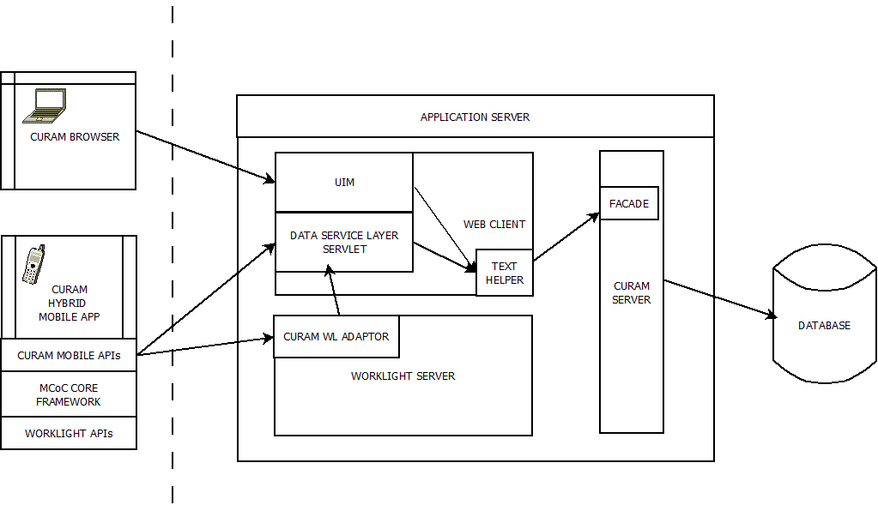
The above diagram outlines how Cúram mobile applications will fit into the existing Cúram architecture.
Mobile applications will be hybrid applications, built using HTML and JavaScript, which can send and retrieve information from Cúram via the new Cúram Data Service Layer.

Development Environment
The development environment for mobile applications will be WorkLight Studio, which supports a development and simulation environment for creating platform independent mobile applications. WorkLight Studio includes support for Dojo Mobile, which provides a widget library and support for developing of mobile applications.
In addition to WorkLight Studio, a number of JavaScript APIs will be available to aid development of Cúram specific mobile applications, including the Mobile CoC Core Framework component as the base for the application and the Cúram Mobile SDK to enable communication with Cúram.
A sample mobile application will be provided, demonstrating features and how to develop with the APIs provided.
    - Cúram Data Service Layer
The Cúram Data Service Layer (CDSL) is a new service that supports invoking Cúram facades via JavaScript AJAX requests. The CDSL comprises of a servlet to handle the requests and a set of JavaScript APIs that can be used by a developer to invoke a façade.
Facades that can be invoked from the servlet must be configured in a white-list. In addition to limiting the set of facades available via the service, the white-list will allow the façade name to be obfuscated by specifying a unique service name, and potentially allow access to the facades to be further restricted based on client type.
The JavaScript APIs will support a direct Request API for invoking the Cúram facades and a Cúram Store. The Cúram Store will be an implementation of a Dojo Store and will provide a standard Dojo layer for performing CRUD operations.
A Dojo Store is a uniform interface for the access and manipulation of stored data, and is intended to abstract data consumers (e.g. widgets) from the concerns of the data provider (e.g. the façade). Dojo widgets will be used to build up the mobile app interface, and the Cúram Store will implement a standard dojo pattern for feeding widgets with data.
In addition, utility methods for handling Cúram specific domains and data formats will be provided.
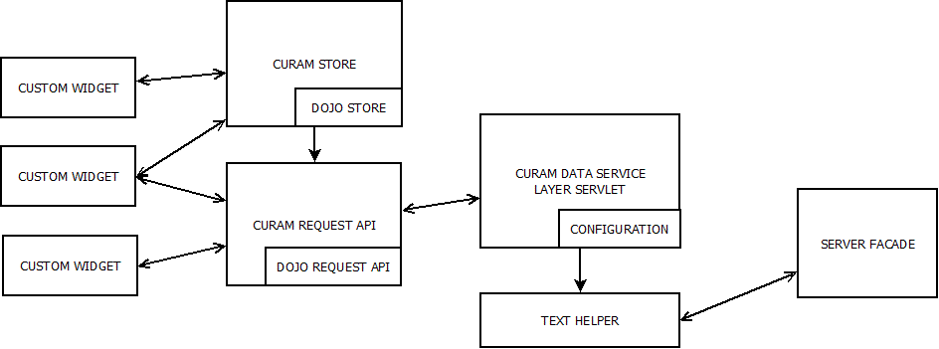
All default features that are provided for facades invoked by UIM will also be catered for by this service, e.g. security, field level security, XSS protection, etc.
    - Third Party Reliance
The Cúram Mobile SDK will be relying on WorkLight, Dojo and Mobile CoC Components to provide additional features to aid development and delivery of mobile applications.

The Data Service Layer proposed for accessing Cúram facades from a mobile application is intended to be a white-listed servlet. This will require configuration information to indicate what facades are white-listed. Initially this white list information will most likely be a simple list of supported facades.
There is potential scope to allow a more granular level of what is exposed on a facade to be defined, i.e. narrowing down the methods available and fields returned. No existing OOTB Curam facades are to be exposed for mobile usage, which means this granular level of definition is not required.
However, we should ensure we do not prevent extending to support this in the future. The intention here is to consider and document the granualar solution, which has potentially more concerns relating to development suppport and CLE/upgrades, in addition to the simple solution to ensure we do not prevent evolution of this going forward.
Data stored by business applications does not apply here. This is an SDK project and data is a customer concern.

